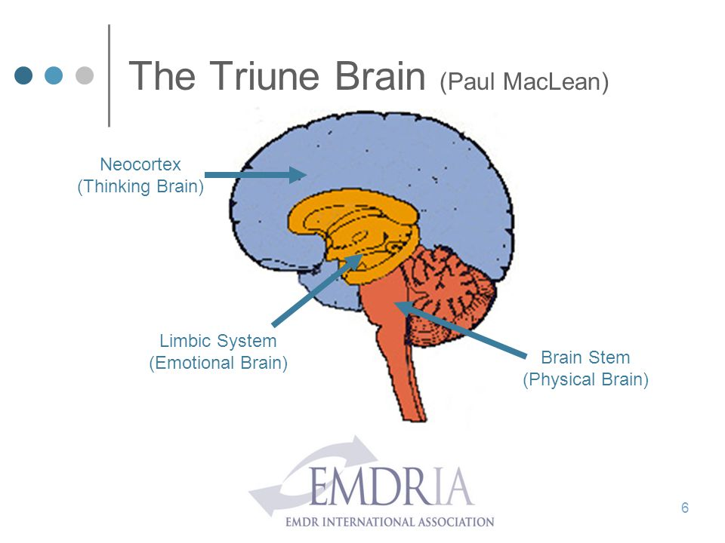
Brain Stem: Lower Level: “Little Brain/Reptilian”: Responsible for arousal, reproduction and homeostasis of the body. First part of fear response. Fight/Flight response. Immediate response to danger. Dangerous emotions = a threat to survival. Basic affects (emotions).
Limbic System: Middle Level: “Emotional Brain”: This is where things either go right or wrong. Very black and white, safe or unsafe, in assessing information, people and situations. No logic. Feelings/emotions are experienced in the cortex and/or body. Sets the emotional tone of the mind. This is where the Hypothalamus and Amygdala (Fight/Flight) are located. The Thalamus is like the conductor of the brain: What do we do with this information? Is it safe? The Amygdala sets the emotional tone of the mind and is crucial for emotional processing.
Neocortex: Third level “Thinking Brain”: Rational thought. Imagination. Language. Information processing. Can see grey area which allows logic, eventually allowing information to go back and forth between left (logic) brain and right (emotions) brain = make good choices. Able to predict future outcomes.
What does this all mean? Trauma disrupts the Thalamus’ ability to bring information up to the Neocortex which is the higher thinking/adult self. This causes the person to be emotionally driven vs. logically driven. When the brain gets fragmented a person develops defenses.
EMDR therapy increases frontal lobe activity. Balances thinking and emotions. Brings you to the present and creates options. Promotes healthy memories and integration. The brain changes after EMDR.

