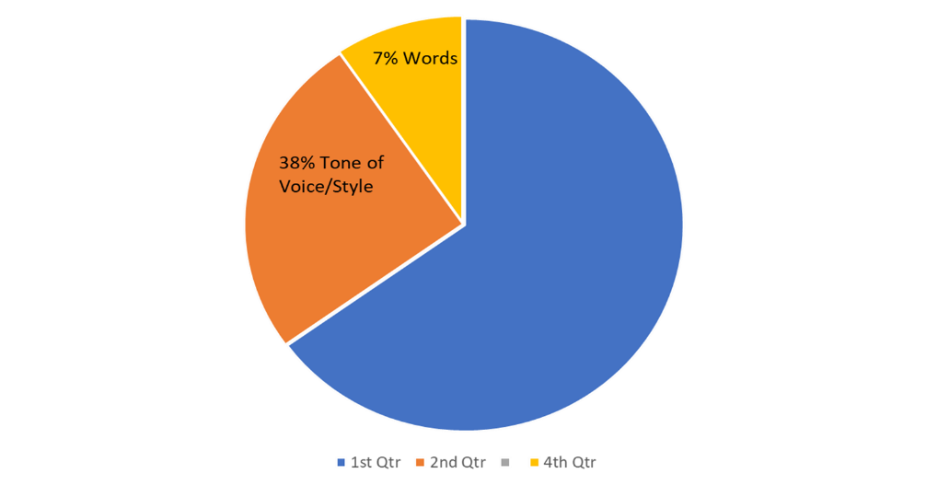
10 C’s to Communication

Coordinate
- Prepare and coordinate as much as possible
- Review steps and present skills
- Set differences aside

Connection
- Find the right time to connect
- Define your higher purpose and need…then bid.

Content
- Peaceful, happiness of satisfaction
- Material presented with assertiveness
- Set some rules
- Define the Problem
- When I …… (I feel, I need, I am willing to do) statements

Context
- Coherent, it's logical. All points are connected and relevant to the main topic, and the tone and flow of the text is consistent
- Form the statement and idea
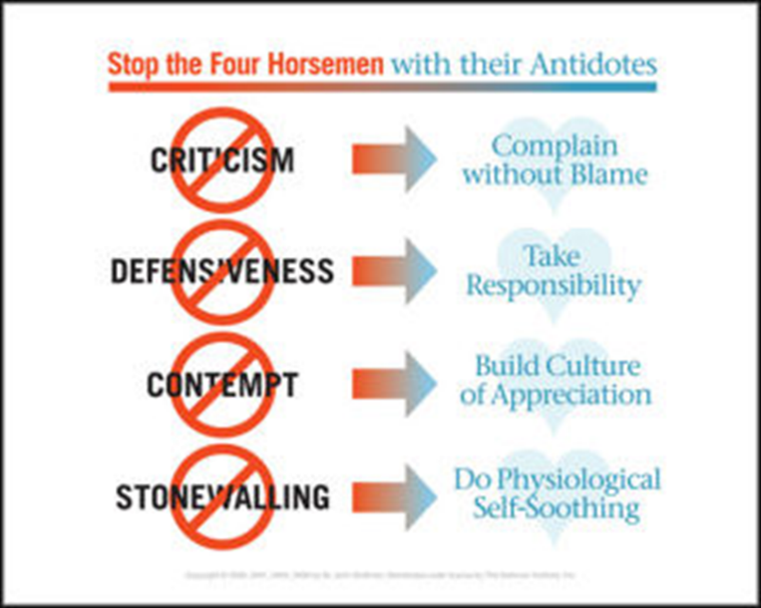
- Storyline or purpose of the conversation
- Define Goals
- Positioning of the content

Control
- Control Thinking Error stories
- Mindful of body language and tone
- Know when you are in FFF before flooded
- Know your triggers to stonewalling or defensiveness
- Actions hijacks words
- Experiences hijacks knowledge

Clear and Crucial
- How Crucial 1-10
- State Facts
- Be clear about your goal or message
- Stick to the point and keep it brief
- Agree on a Win Win action plan

Commitment
- Strong belief in something, a promise to do something
- How high is the stake?
- List your top ABC’s
- List Pro’s and Con’s
- Known Values

Correspond
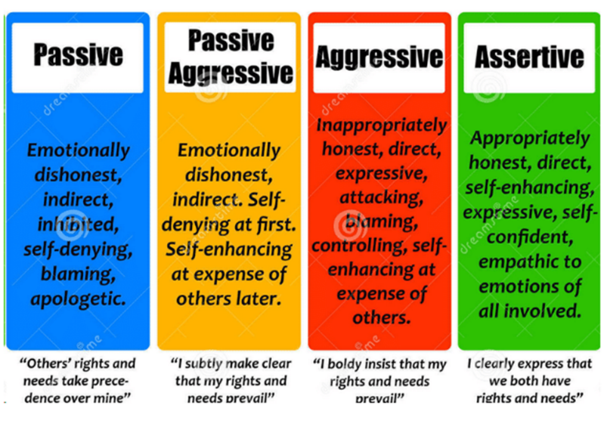
- Seek to understand before understood -Habit 5
- Active listening and reflective skills (handout at end)
- Assertive connection
- Stay in a safe space
- Back and Forth
- Probing and Restating
- Know your triggers
- Stay logical

Courteous
- Polite speech or action, especially one required by a settlement
- Calm assertive action
- Quality of manners or social conduct
- Kindness
- Respect, understanding, and with consideration

Closure
- Greater Influence
- Solutions to Problems
- Clarity
- Faster Conflict Problem
- Seeing Others Perspective
- Love, Belonging, and Healing
- Mutual Understanding
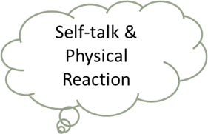
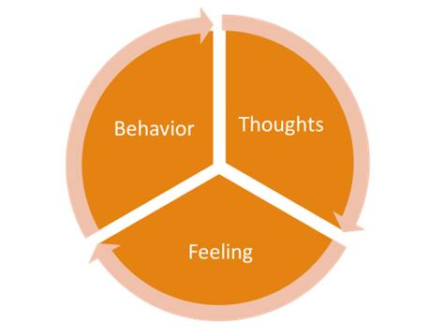
- Win-Win
- Rephrase, Reflect, Repair
- Body Language with Reflection on Feelings with Ears, Eyes, and Heart
- Focus on the speaker
If you get stuck, just repeat what is being displayed
- Don’t be afraid of silence, just wait and listen
- Don’t correct the emotion just make statements
- Use language like…You seem... You sound... What I am hearing is...You're feeling now…
- Do Not advise, reply, solve, fix, change, judge, agree, disagree, analyze, or question

Caryl Ann Duvall LCMHC, CFLE paperbackconnentions.com ©

