Sleep Hygiene Routine-Bed is Just for Sleep Nothing Else
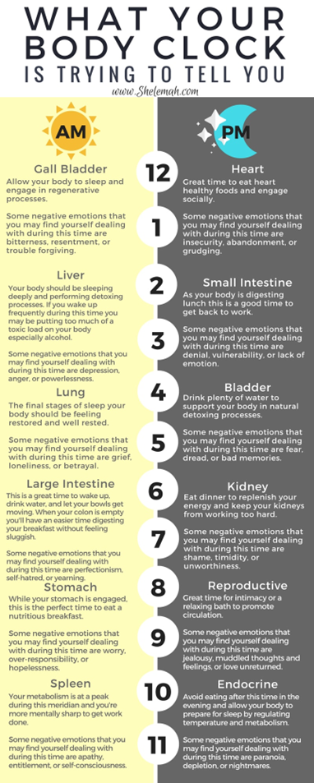
Stretch or Hot Bath
Blue Blocker Glasses before bedtime
Electronics/Lights off 1-2 hours before bedtime
Relaxation Techniques
Hyper-sleep (YouTube)/Mindfulness
Avoid Caffeine
Reduce or Avoid Naps
20 Minute Rule (Get out of your bed after 20 minutes of not sleeping)
Read for 30 mins or less
Mind dump worries/emotions/gratitude
Lower Social Interactions
Day Time/ Auto Piolet
Cool Bedroom
Bilateral Tapping (Each hemisphere of brain is used and begins calming the FFF brain)
Circadian Rhythm
Supplements
Morning Routine
Wake up at same time
Light for 20 mins-First Thing
Avoid upsetting news and work emails
Read or listen to something motivational (podcast, music, mediation)
Exercise and hydrate
How to make this a great day
Journal/Planner-Who can I connect with today?
How can I manage stress and tension within myself and my family unit?

